**Fritzing diagram for temperature sensor:**

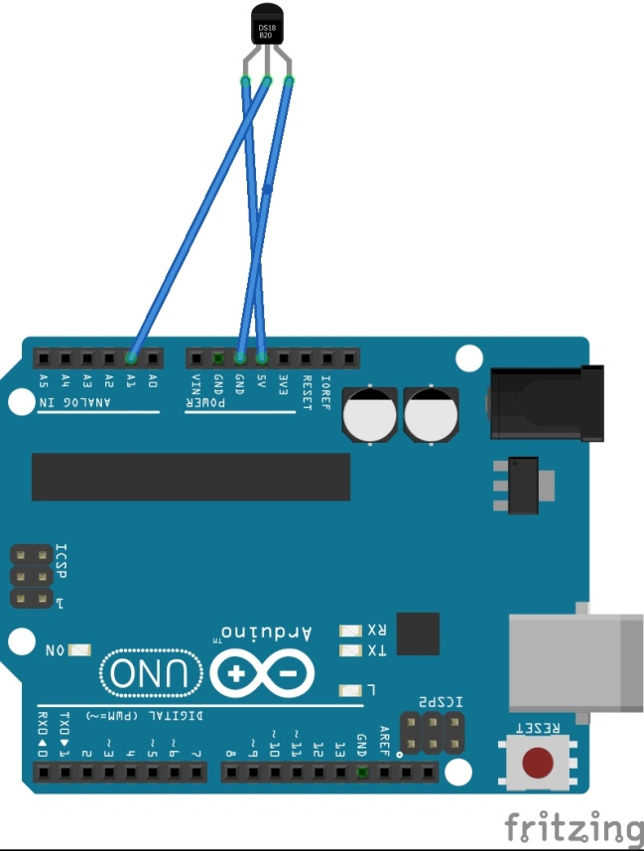

**Uno Code-**

int temppin=0;

float temp;

void setup()

{ Serial.begin(9600); }

void loop() {

temp=analogRead(temppin); // Reading data from the sensor.This voltage is stored as a 10bit number

temp=(5.0*temp*1000.0)/(1024*10);

/* 5*temp/1024 is to convert the 10 bit number to a voltage reading.

This is multiplied by 1000 to convert it to millivolt.

We then divide it by 10 beacuse each degree rise results in a 10 millivolt increase. */

Serial.println(temp);

delay(1000);// This is because we dont want a continuous stream of data

}